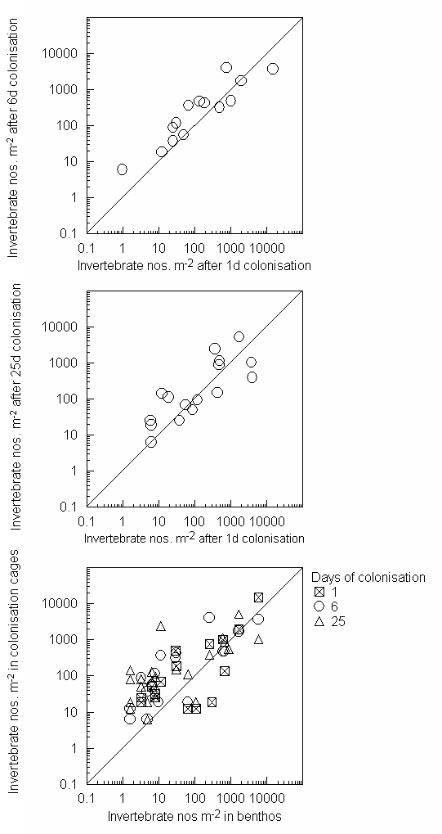
Appendix Ia. Abundances of common invertebrates in control “unseeded” colonisation cages after 1, 6 and 25 days of exposure and in the benthos (zero counts have been excluded). Diagonal lines represent 1:1 relationships.

Appendix Ib. Absolute mean abundances m⁻² in the benthos at the start and end of the field experiment and densities in experimental enclosure/exclosure cages. See Methods for details.
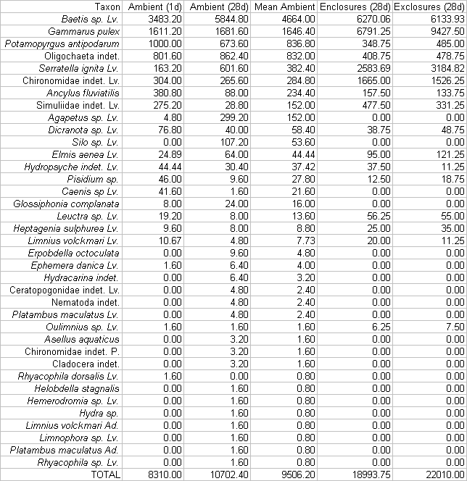

Appendix IIa Food web data for the Bere Stream. Vertices refer to species nodes 1-142 and in the pairwise columns the left-hand data refer to resources and the right hand to consumers. The data sources for nodes and links are listed in Methods.
*Vertices 142
1 "Hydridae"
2 "Ostracoda"
3 "Copepoda"
4 "Cladocera"
5 "Tubificidae"
6 "Polycelis_nigra"
7 "Asellus_aquaticus"
8 "Potamopyrgus_antipodarium"
9 "Polycelis_felina"
10 "Gammarus_pulex"
11 "Enchytraeus_grp."
12 "Lumbriculus_variegatus"
13 "Dendrocoelom_lacteum"
14 "FPOM"
15 "CPOM"
16 "N._gregaria"
17 "N._menisculis"
18 "N._tripunctata"
19 "N._lanceolata"
20 "A._pediculis"
21 "D._vulgaris"
22 "G._olivaceum"
23 "F._elliptica"
24 "F._vaucheriae"
25 "C._placentula"
26 "N._dissipata"
27 "N._perminuta"
28 "M._varians"
29 "C._solea"
30 "R._curvata"
31 "G._incrustans"
32 "Fungi"
33 "Chrococcus"
34 "Spirulina"
35 "Lymnaea_palustris"
36 "A._ovalis"
37 "A._lanceolata"
38 "A._elliptica"
39 "F._leptostauron"
40 "S._ovalis"
41 "C._minuta"
42 "Gyrosigma"
43 "Fungal_spores"
44 "algal_cysts"
45 "Physa_fontinalis"
46 "Ancylus_fluviatilis"
47 "Sphaerium_corneum"
48 "Pisidium_milium"
49 "C._lanceolata"
50 "Pisidium_subtruncatum"
51 "Pisidium_nitidum"
52 "Nais_alpina"
53 "S._ulva"
54 "Nais_elinguis"
55 "Stylaria_lacustris"
56 "Tubifex_ignotus"
57 "Psammoryctides_barbatus"
58 "Limnodrilus_hoffmeisteri"
59 "Spirosperma_ferox"
60 "Spirosperma_velutinous"
61 "Aulodrilus_pluriseta"
62 "Propappus_volki"
63 "Stylodrilus_heringianus"
64 "Stilodrilus_brachystylus"
65 "Lumbricidae"
66 "Piscicola_geometra"
67 "Gasterosteus"
68 "Lampetra_planeri"
69 "Salmo_trutta"
70 "Anguilla_anguilla"
71 "Cottus_gobio"
72 "Theromyzon_tessulatum"
73 "Ephemera_vulgata"
74 "Simulium_(Wilhemia)_sp"
75 "Simulium_(Simulium)_ornatum_grp"
76 "Dicranota"
77 "Protozoa"
78 "Goera sp"
79 "Silo sp"
80 "Agapetus sp"
81 "Glossiphonia_complanata"
82 "Helobdella_stagnalis"
83 "Erpobdella_octoculata"
84 "Asellus_meridianus"
85 "Baetis_vernus"
86 "Baetis_rhodani"
87 "Heptagenia_sulphurea"
88 "Paraleptophlebia_submarginata"
89 "Paraleptophlebia_cincta"
90 "Seratella_ignita"
91 "Ephemera_danica"
92 "Caenis_luctuosa"
93 "Caenis_rivulorum"
94 "Nemurella_pictetii"
95 "Leuctra_geniculata"
96 "Leuctra_fusca"
97 "Isoperla_grammatica"
98 "Rhyacophila_dorsalis"
99 "Brillia_modesta"
100 "Macropelopia"
101 "Calopteryx_splendens"
102 "Velia_caprai"
103 "Terrestrial_invertebrates"
104 "Brychius_elevatus"
105 "Apsectrotanypus_trifascipennis"
106 "Thiennemannimyia_grp"
107 "Oreodytes_sanmarkii"
108 "Agabus_didymus"
109 "Limnephilus_lunatus"
110 "Corixidae"
111 "Ilybius_sp."
112 "Sialis_lutaria"
113 "Ceratopogonidae"
114 "Hydracarina"
115 "Platambus_maculatus"
116 "Prodiamesa_olivacea"
117 "Polypedilum_sp"
118 "Micropsectra_sp"
119 "Helophorus_brevipalpis"
120 "Elmis_aenea"
121 "Limnius_volckmari"
122 "Sisyra_sp."
123 "Lype_reducta"
124 "Hydropsyche_pellucidula"
125 "Hydropsyche_siltalai"
126 "Drusus_annulatus"
127 "Potamophylax cingulatus"
128 "Halesus radiatus"
129 "Odontocerum_albicorne"
130 "Lepidostoma_hirtum"
131 "Brachycentrus_subnubilus"
132 "Sericostoma_personatum"
133 "Brillia_longifurca"
134 "Limnophila"
135 "Pericoma_trivialis"
136 "Eukiefferiella_grp"
137 "Paracladius_conversus"
138 "Tvetenia_calvescens"
139 "Rheotanytarsus"
140 "Oxycera_sp"
141 "Hemerodromia_grp"
142 "Atalanta_grp"
*Arcs
2 1 1
3 1 1
4 1 1
5 1 1
7 6 1
5 6 1
8 6 1
7 9 1
5 9 1
8 9 1
10 9 1
5 9 1
11 9 1
12 9 1
7 13 1
14 8 1
15 8 1
16 8 1
17 8 1
18 8 1
19 8 1
20 8 1
21 8 1
22 8 1
23 8 1
24 8 1
25 8 1
26 8 1
27 8 1
28 8 1
29 8 1
30 8 1
31 8 1
32 8 1
33 8 1
34 8 1
14 35 1
15 35 1
16 35 1
17 35 1
18 35 1
19 35 1
20 35 1
36 35 1
21 35 1
37 35 1
38 35 1
22 35 1
23 35 1
24 35 1
39 35 1
25 35 1
26 35 1
27 35 1
28 35 1
40 35 1
29 35 1
30 35 1
41 35 1
42 35 1
31 35 1
32 35 1
43 35 1
44 35 1
33 35 1
34 35 1
14 45 1
15 45 1
16 45 1
17 45 1
18 45 1
19 45 1
20 45 1
36 45 1
21 45 1
37 45 1
38 45 1
22 45 1
23 45 1
24 45 1
39 45 1
25 45 1
26 45 1
27 45 1
28 45 1
40 45 1
29 45 1
30 45 1
41 45 1
42 45 1
31 45 1
32 45 1
43 45 1
44 45 1
33 45 1
34 45 1
14 46 1
15 46 1
16 46 1
17 46 1
18 46 1
19 46 1
20 46 1
21 46 1
22 46 1
23 46 1
25 46 1
26 46 1
27 46 1
28 46 1
30 46 1
31 46 1
32 46 1
43 46 1
44 46 1
33 46 1
14 47 1
16 47 1
19 47 1
25 47 1
28 47 1
30 47 1
43 47 1
33 47 1
14 48 1
16 48 1
17 48 1
18 48 1
19 48 1
20 48 1
21 48 1
22 48 1
23 48 1
25 48 1
26 48 1
27 48 1
28 48 1
30 48 1
49 48 1
43 48 1
14 50 1
16 50 1
17 50 1
18 50 1
19 50 1
20 50 1
21 50 1
22 50 1
23 50 1
25 50 1
26 50 1
27 50 1
28 50 1
30 50 1
49 50 1
43 50 1
14 50 1
14 51 1
16 51 1
17 51 1
18 51 1
19 51 1
20 51 1
21 51 1
22 51 1
23 51 1
25 51 1
26 51 1
27 51 1
28 51 1
30 51 1
49 51 1
43 51 1
14 52 1
15 52 1
16 52 1
17 52 1
18 52 1
19 52 1
20 52 1
21 52 1
22 52 1
23 52 1
24 52 1
25 52 1
26 52 1
27 52 1
28 52 1
53 52 1
40 52 1
30 52 1
42 52 1
32 52 1
43 52 1
33 52 1
34 52 1
14 54 1
15 54 1
16 54 1
17 54 1
18 54 1
19 54 1
20 54 1
21 54 1
22 54 1
23 54 1
24 54 1
25 54 1
26 54 1
27 54 1
28 54 1
53 54 1
40 54 1
30 54 1
42 54 1
32 54 1
43 54 1
33 54 1
34 54 1
14 55 1
14 5 1
44 5 1
41 5 1
25 5 1
29 5 1
33 5 1
15 5 1
23 5 1
24 5 1
32 5 1
28 5 1
26 5 1
16 5 1
19 5 1
17 5 1
27 5 1
18 5 1
33 5 1
30 5 1
40 5 1
34 5 1
14 56 1
14 57 1
14 58 1
14 59 1
14 60 1
14 61 1
14 11 1
14 62 1
14 12 1
15 12 1
17 12 1
19 12 1
20 12 1
22 12 1
24 12 1
25 12 1
27 12 1
28 12 1
30 12 1
32 12 1
34 12 1
37 12 1
38 12 1
36 12 1
23 12 1
39 12 1
43 12 1
26 12 1
16 12 1
18 12 1
34 12 1
34 12 1
34 12 1
34 12 1
34 12 1
34 12 1
34 12 1
34 12 1
14 63 1
14 64 1
14 65 1
67 66 1
68 66 1
69 66 1
70 66 1
71 66 1
14 72 1
15 72 1
16 72 1
18 72 1
19 72 1
20 72 1
38 72 1
22 72 1
23 72 1
24 72 1
25 72 1
26 72 1
27 72 1
28 72 1
40 72 1
29 72 1
30 72 1
42 72 1
32 72 1
33 72 1
91 72 1
73 72 1
2 72 1
74 72 1
75 72 1
76 72 1
77 72 1
5 72 1
10 72 1
131 72 1
117 72 1
14 81 1
15 81 1
16 81 1
18 81 1
19 81 1
20 81 1
38 81 1
22 81 1
23 81 1
24 81 1
25 81 1
26 81 1
27 81 1
28 81 1
40 81 1
29 81 1
30 81 1
42 81 1
32 81 1
33 81 1
91 81 1
73 81 1
2 81 1
74 81 1
75 81 1
76 81 1
77 81 1
5 81 1
10 81 1
131 81 1
117 81 1
8 81 1
48 81 1
50 81 1
51 81 1
35 81 1
45 81 1
56 81 1
14 82 1
15 82 1
16 82 1
18 82 1
19 82 1
20 82 1
38 82 1
22 82 1
23 82 1
24 82 1
25 82 1
26 82 1
27 82 1
28 82 1
40 82 1
29 82 1
30 82 1
42 82 1
32 82 1
33 82 1
91 82 1
73 82 1
2 82 1
74 82 1
75 82 1
76 82 1
77 82 1
5 82 1
10 82 1
131 82 1
117 82 1
8 82 1
48 82 1
50 82 1
51 82 1
35 82 1
45 82 1
56 82 1
14 83 1
15 83 1
16 83 1
18 83 1
19 83 1
20 83 1
38 83 1
22 83 1
23 83 1
24 83 1
25 83 1
26 83 1
27 83 1
28 83 1
40 83 1
29 83 1
30 83 1
42 83 1
32 83 1
33 83 1
91 83 1
73 83 1
2 83 1
74 83 1
75 83 1
76 83 1
77 83 1
5 83 1
10 83 1
131 83 1
117 83 1
14 7 1
15 7 1
16 7 1
17 7 1
18 7 1
19 7 1
20 7 1
21 7 1
38 7 1
22 7 1
23 7 1
24 7 1
25 7 1
26 7 1
27 7 1
28 7 1
29 7 1
30 7 1
41 7 1
31 7 1
32 7 1
43 7 1
33 7 1
14 84 1
15 84 1
16 84 1
17 84 1
18 84 1
19 84 1
20 84 1
21 84 1
38 84 1
22 84 1
23 84 1
24 84 1
25 84 1
26 84 1
27 84 1
28 84 1
29 84 1
30 84 1
41 84 1
31 84 1
32 84 1
43 84 1
33 84 1
14 10 1
15 10 4
16 10 1
17 10 1
18 10 1
19 10 1
20 10 1
21 10 1
37 10 1
38 10 1
22 10 1
23 10 1
24 10 1
25 10 1
26 10 1
27 10 1
28 10 1
40 10 1
29 10 1
30 10 1
31 10 1
32 10 1
43 10 1
44 10 1
33 10 1
34 10 1
14 85 1
15 85 1
16 85 1
17 85 1
18 85 1
19 85 1
20 85 1
22 85 1
23 85 1
25 85 1
26 85 1
27 85 1
30 85 1
31 85 1
32 85 1
43 85 1
33 85 1
14 86 1
15 86 1
16 86 1
17 86 1
18 86 1
19 86 1
20 86 1
22 86 1
23 86 1
25 86 1
26 86 1
27 86 1
30 86 1
31 86 1
32 86 1
43 86 1
33 86 1
14 87 1
15 87 1
16 87 1
22 87 1
25 87 1
26 87 1
31 87 1
32 87 1
33 87 1
33 88 1
15 88 1
14 88 1
33 89 1
15 89 1
14 89 1
14 90 1
15 90 1
16 90 1
17 90 1
18 90 1
19 90 1
20 90 1
22 90 1
23 90 1
25 90 1
26 90 1
27 90 1
30 90 1
31 90 1
32 90 1
43 90 1
33 90 1
14 91 1
15 91 1
16 91 1
17 91 1
18 91 1
19 91 1
20 91 1
21 91 1
22 91 1
23 91 1
25 91 1
26 91 1
27 91 1
28 91 1
53 91 1
40 91 1
30 91 1
31 91 1
32 91 1
43 91 1
33 91 1
34 91 1
14 73 1
15 73 1
16 73 1
17 73 1
18 73 1
19 73 1
20 73 1
21 73 1
22 73 1
23 73 1
25 73 1
26 73 1
27 73 1
28 73 1
53 73 1
40 73 1
30 73 1
31 73 1
32 73 1
43 73 1
33 73 1
34 73 1
14 92 1
14 92 1
14 93 1
14 93 1
14 94 1
15 94 1
14 95 1
15 95 1
33 95 1
14 96 1
15 96 1
33 96 1
98 97 1
99 97 1
100 97 1
3 97 1
4 97 1
2 97 1
96 97 1
74 97 1
86 97 1
133 97 1
15 97 1
14 97 1
111 97 1
130 97 1
28 97 1
107 97 1
139 97 1
75 97 1
74 97 1
74 97 1
74 97 1
74 97 1
74 97 1
2 101 1
4 101 1
3 101 1
86 101 1
33 101 1
15 101 1
14 101 1
87 101 1
95 101 1
107 101 1
5 101 1
103 102 1
63 102 1
100 104 1
105 104 1
106 104 1
99 104 1
7 104 1
5 104 1
12 104 1
4 104 1
100 107 1
105 107 1
106 107 1
99 107 1
7 107 1
5 107 1
12 107 1
4 107 1
100 108 1
105 108 1
106 108 1
99 108 1
7 108 1
5 108 1
12 108 1
4 108 1
109 108 1
110 108 1
101 108 1
111 108 1
3 108 1
112 108 1
85 108 1
86 108 1
113 108 1
114 108 1
9 108 1
6 108 1
94 108 1
10 108 1
92 108 1
93 108 1
82 108 1
11 108 1
105 115 1
99 115 1
116 115 1
117 115 1
118 115 1
113 115 1
74 115 1
94 115 1
114 115 1
103 115 1
5 115 1
100 111 1
105 111 1
106 111 1
99 111 1
7 111 1
5 111 1
12 111 1
4 111 1
109 111 1
112 111 1
108 111 1
110 111 1
11 111 1
100 119 1
105 119 1
106 119 1
99 119 1
7 119 1
5 119 1
12 119 1
4 119 1
14 120 1
15 120 1
20 120 1
21 120 1
22 120 1
25 120 1
30 120 1
33 120 1
14 121 1
15 121 1
17 121 1
18 121 1
105 112 1
99 112 1
116 112 1
117 112 1
118 112 1
113 112 1
74 112 1
94 112 1
114 112 1
115 112 1
4 112 1
3 112 1
103 112 1
110 112 1
11 112 1
5 112 1
14 112 1
15 112 1
18 112 1
19 112 1
20 112 1
21 112 1
23 112 1
25 112 1
26 112 1
27 112 1
28 112 1
53 112 1
32 112 1
2 112 1
43 112 1
14 122 1
24 122 1
74 98 1
3 98 1
4 98 1
2 98 1
14 98 1
15 98 1
20 98 1
95 98 1
86 98 1
33 98 1
107 98 1
139 98 1
75 98 1
14 123 1
14 124 1
15 124 1
16 124 1
17 124 1
18 124 1
19 124 1
20 124 1
37 124 1
22 124 1
23 124 1
24 124 1
25 124 1
26 124 1
27 124 1
28 124 1
53 124 1
30 124 1
31 124 1
32 124 1
43 124 1
33 124 1
34 124 1
14 125 1
15 125 1
16 125 1
17 125 1
18 125 1
19 125 1
20 125 1
37 125 1
22 125 1
23 125 1
24 125 1
25 125 1
26 125 1
27 125 1
28 125 1
53 125 1
30 125 1
31 125 1
32 125 1
43 125 1
33 125 1
34 125 1
14 126 1
15 126 1
24 126 1
14 109 1
15 109 1
16 109 1
18 109 1
19 109 1
20 109 1
38 109 1
22 109 1
23 109 1
25 109 1
26 109 1
30 109 1
31 109 1
33 109 1
12 109 1
11 109 1
103 127 1
14 127 1
15 127 1
17 127 1
18 127 1
19 127 1
20 127 1
22 127 1
23 127 1
24 127 1
25 127 1
26 127 1
28 127 1
30 127 1
32 127 1
43 127 1
33 127 1
14 128 1
15 128 1
16 128 1
17 128 1
18 128 1
19 128 1
20 128 1
37 128 1
22 128 1
23 128 1
24 128 1
25 128 1
26 128 1
27 128 1
28 128 1
30 128 1
31 128 1
32 128 1
33 128 1
34 128 1
15 129 1
15 130 1
38 130 1
37 130 1
25 130 1
23 130 1
39 130 1
24 130 1
32 130 1
22 130 1
26 130 1
16 130 1
19 130 1
17 130 1
27 130 1
18 130 1
2 131 1
14 131 1
15 131 1
16 131 1
17 131 1
18 131 1
19 131 1
20 131 1
36 131 1
21 131 1
37 131 1
38 131 1
22 131 1
23 131 1
24 131 1
25 131 1
26 131 1
27 131 1
28 131 1
40 131 1
29 131 1
30 131 1
49 131 1
41 131 1
31 131 1
32 131 1
43 131 1
33 131 1
34 131 1
14 132 1
15 132 1
16 132 1
17 132 1
18 132 1
19 132 1
20 132 1
37 132 1
22 132 1
23 132 1
25 132 1
26 132 1
27 132 1
28 132 1
29 132 1
30 132 1
31 132 1
32 132 1
43 132 1
44 132 1
33 132 1
34 132 1
99 76 1
133 76 1
116 76 1
117 76 1
118 76 1
113 76 1
100 76 1
74 76 1
75 76 1
3 76 1
4 76 1
2 76 1
94 76 1
14 134 1
15 134 1
16 134 1
17 134 1
20 134 1
22 134 1
23 134 1
25 134 1
27 134 1
28 134 1
30 134 1
41 134 1
42 134 1
31 134 1
32 134 1
43 134 1
33 134 1
14 135 1
15 135 1
17 135 1
18 135 1
38 135 1
22 135 1
25 135 1
27 135 1
28 135 1
30 135 1
14 113 1
99 105 1
116 105 1
117 105 1
118 105 1
2 105 1
113 105 1
74 105 1
75 105 1
3 105 1
4 105 1
94 105 1
105 100 1
99 100 1
116 100 1
117 100 1
4 100 1
3 100 1
118 100 1
113 100 1
74 100 1
75 100 1
94 100 1
14 100 1
15 100 1
18 100 1
20 100 1
36 100 1
22 100 1
25 100 1
27 100 1
28 100 1
29 100 1
31 100 1
32 100 1
2 100 1
33 100 1
105 106 1
99 106 1
116 106 1
117 106 1
118 106 1
4 106 1
3 106 1
113 106 1
74 106 1
75 106 1
94 106 1
14 106 1
15 106 1
18 106 1
20 106 1
36 106 1
22 106 1
25 106 1
27 106 1
28 106 1
29 106 1
31 106 1
32 106 1
2 106 1
33 106 1
14 133 1
15 133 1
14 99 1
15 99 1
14 136 1
14 137 1
14 138 1
14 116 1
15 116 1
16 116 1
18 116 1
20 116 1
22 116 1
25 116 1
26 116 1
28 116 1
30 116 1
31 116 1
32 116 1
43 116 1
33 116 1
14 117 1
15 117 1
36 117 1
25 117 1
26 117 1
28 117 1
31 117 1
32 117 1
33 117 1
14 118 1
14 139 1
14 74 1
16 74 1
17 74 1
18 74 1
19 74 1
20 74 1
21 74 1
38 74 1
22 74 1
23 74 1
24 74 1
39 74 1
25 74 1
26 74 1
27 74 1
28 74 1
29 74 1
30 74 1
31 74 1
32 74 1
33 74 1
14 75 1
16 75 1
17 75 1
18 75 1
19 75 1
20 75 1
21 75 1
38 75 1
22 75 1
23 75 1
24 75 1
39 75 1
25 75 1
26 75 1
27 75 1
28 75 1
29 75 1
30 75 1
31 75 1
32 75 1
33 75 1
25 140 1
14 140 1
14 141 1
14 142 1
26 68 1
27 68 1
5 68 1
14 68 1
71 69 4
2 69 1
3 69 1
4 69 1
110 69 1
109 69 1
48 69 1
50 69 1
51 69 1
67 69 1
70 69 1
115 69 1
100 69 1
94 69 1
103 69 1
68 69 1
83 69 1
35 69 1
74 69 1
75 69 1
128 69 1
47 69 1
46 69 1
7 69 1
10 69 1
97 69 1
95 69 1
96 69 1
86 69 1
90 69 1
112 69 1
132 69 1
131 69 1
124 69 1
98 69 1
139 69 1
115 69 1
103 69 1
108 69 1
119 69 1
120 69 1
105 69 1
84 69 1
142 69 1
61 69 1
85 69 1
131 69 1
99 69 1
104 69 1
93 69 1
101 69 1
113 69 1
13 69 1
76 69 1
126 69 1
91 69 1
136 69 1
81 69 1
82 69 1
141 69 1
87 69 1
114 69 1
125 69 1
111 69 1
130 69 1
121 69 1
134 69 1
65 69 1
123 69 1
118 69 1
129 69 1
107 69 1
140 69 1
135 69 1
89 69 1
45 69 1
9 69 1
117 69 1
127 69 1
122 69 1
106 69 1
5 69 1
106 69 1
138 69 1
102 69 1
1 69 1
7 71 1
116 71 1
117 71 1
118 71 1
74 71 1
10 71 4
75 71 1
99 71 1
35 71 1
46 71 1
91 71 1
46 71 1
92 71 1
93 71 1
98 71 1
87 71 1
84 71 1
78 71 1
48 71 1
117 71 1
51 71 1
52 71 1
136 71 1
114 71 1
113 71 1
105 71 1
100 71 1
112 71 1
124 71 1
132 71 1
125 71 1
126 71 1
111 71 1
4 71 1
3 71 1
8 71 4
110 71 1
85 71 1
86 71 1
2 71 1
90 71 1
71 70 1
67 70 1
68 70 1
69 70 1
83 70 1
35 70 1
74 70 1
75 70 1
128 70 1
47 70 1
46 70 1
7 70 1
10 70 1
97 70 1
95 70 1
96 70 1
86 70 1
90 70 1
112 70 1
132 70 1
131 70 1
124 70 1
98 70 1
139 70 1
115 70 1
103 70 1
7 67 1
10 67 1
2 67 1
4 67 1
3 67 1
47 67 1
45 67 1
5 67 1
47 67 1
8 67 1
103 67 1
14 67 1
15 67 1
16 67 1
17 67 1
18 67 1
19 67 1
23 67 1
24 67 1
39 67 1
114 67 1
4 3 1
11 3 1
14 3 1
14 4 1
14 2 1
15 2 1
16 2 1
20 2 1
38 2 1
23 2 1
25 2 1
14 110 1
14 78 1
15 78 1
19 78 1
24 78 1
21 78 1
28 78 1
14 79 1
17 79 1
18 79 1
19 79 1
20 79 1
21 79 1
22 79 1
23 79 1
24 79 1
25 79 1
26 79 1
27 79 1
28 79 1
29 79 1
30 79 1
31 79 1
36 79 1
37 79 1
38 79 1
39 79 1
40 79 1
41 79 1
42 79 1
43 79 1
44 79 1
79 71 1
79 69 1
17 80 1
18 80 1
19 80 1
20 80 1
21 80 1
22 80 1
23 80 1
24 80 1
25 80 1
26 80 1
27 80 1
28 80 1
29 80 1
30 80 1
31 80 1
36 80 1
37 80 1
38 80 1
39 80 1
40 80 1
41 80 1
42 80 1
43 80 1
44 80 1
80 71 1

Appendix IIb. Numbers of links and species in a set of highly-resolved freshwater food webs. See Methods for details.
